Data Flow Diagram & User Stories
Date | 25 September 2026
Team ID | SWTID-2026-5541
Project Name | FitTrack
Maximum Marks | 4 Marks

1. Data Flow Diagram
A Data Flow Diagram (DFD) represents how information moves through the AI FitTrack system. It shows how user information, fitness goals, workout data and progress details enter the system, are processed, stored and returned to the user.

DFD Level 0 – AI FitTrack
The main components of the AI FitTrack DFD are:
- User: Provides registration details, personal information, fitness goals and workout activities.
- AI FitTrack System: Processes user information and manages the main application functions.
- Database: Stores user profiles, workout records, fitness goals and progress information.
- AI Engine: Analyses user information and fitness goals to generate personalized workout recommendations.
- Output: The user receives personalized workout plans, progress reports and fitness insights.

2. User Flow Diagram
The user flow represents the step-by-step journey of a user while interacting with the AI FitTrack application.

User Flow
- Start – The user starts the AI FitTrack application.
- Open Application – The user accesses the application.
- Sign Up / Login – A new user creates an account, while an existing user logs in.
- Enter Details – The user provides required information such as name, email and password.
- Email Validation – The system validates the entered email information.
- Email / OTP Verification – The user verifies the account using email or OTP.
- Complete Profile – The user enters fitness-related information such as height, weight, fitness goals and other required details.
- AI Processing – The AI engine analyses the user's profile and fitness goals.
- Personalized Workout Plan – The system generates suitable workout recommendations.
- Dashboard – The user accesses the dashboard.
- Track Progress – The user records workouts and monitors fitness progress.

Error Handling
If the email or verification details are invalid, the system displays an error message and allows the user to correct the information and continue.
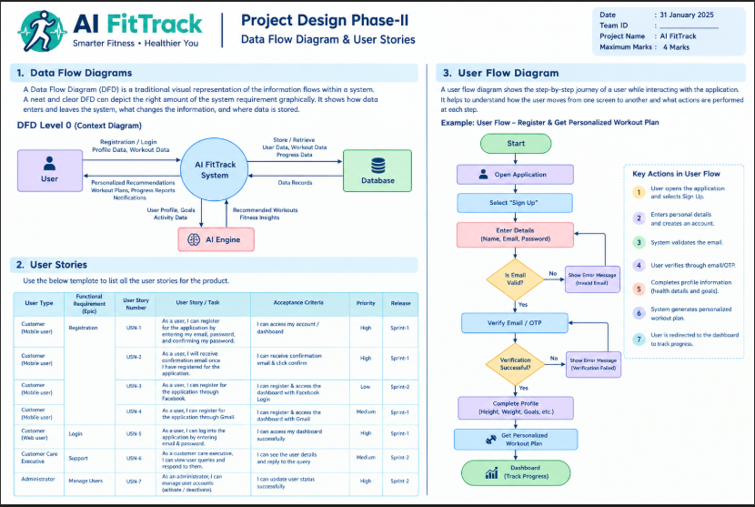

3. User Stories
The following user stories describe the main interactions of AI FitTrack. The reference template uses acceptance criteria, priority and sprint/release information for each story.
User Type | Functional Requirement | User Story No. | User Story / Task | Acceptance Criteria | Priority | Release
Customer | Registration | USN-1 | As a user, I can register by entering my email and password. | User can create an account successfully. | High | Sprint-1
Customer | Login | USN-2 | As a user, I can log in using my registered email and password. | User can access the dashboard successfully. | High | Sprint-1
Customer | Profile | USN-3 | As a user, I can enter and update my fitness information. | Profile information is saved successfully. | High | Sprint-1
Customer | Fitness Goals | USN-4 | As a user, I can set my fitness goals. | Selected fitness goals are stored in the system. | Medium | Sprint-1
Customer | AI Recommendation | USN-5 | As a user, I can receive personalized workout recommendations. | System generates workouts based on my profile and goals. | High | Sprint-2
Customer | Workout Tracking | USN-6 | As a user, I can record my completed workouts. | Workout details are stored with date and duration. | High | Sprint-2
Customer | Progress Tracking | USN-7 | As a user, I can view my workout history and progress. | Dashboard displays fitness progress and activity records. | High | Sprint-2
Customer | Notifications | USN-8 | As a user, I can receive workout reminders and fitness guidance. | Relevant reminders and guidance are displayed. | Medium | Sprint-3
Administrator | User Management | USN-9 | As an administrator, I can manage registered users. | Administrator can view and manage user accounts. | High | Sprint-3

4. Expected Outcome
AI FitTrack provides a simple fitness-management experience in which users can create an account, maintain their fitness profile, receive personalized workout recommendations, record their activities and monitor their progress through a centralized dashboard.

